How does household labour market behaviour respond to child-related transfers?

Joshua Clyne (zjq446)

May 31, 2024

Seminar: Economics of the Welfare State

Department of Economics

University of Copenhagen

Characters:

Main Text:

35,864

Appendix: XX

**Abstract**

This paper investigates the labour supply responses of households with children to child-related transfer schemes. It examines how intra-household decisionmaking processes influence these responses using a dynamic structural model. The study compares the effects of transfers that are conditional on market work with those that unconditional, and examines their impact on male and female labor supply. Additionally, it incorporates a household bargaining model with limited commitment to understand the dynamics of intra-household negotiations. The findings suggest that child-related transfers can significantly influence labour supply decisions, with the nature of the transfer scheme playing a crucial role in determining these effects.

**Contents**

**1 Introduction** **3**

**2 Motivation** **3**

2.1 Understanding child-related transfers 3

2.2 Family labour supply through the lens of dynamic economic models 5

2.3 Modelling decision-making within the household 7

**3 Model** **8**

3.1 Setup 8

3.2 Child-related transfers 10

3.3 Bellman equations 10

3.4 Solving the unconstrained problem of couples 11

3.5 Checking the participation constraints 12

**4 Results** **13**

4.1 Solution method 13

4.2 Calibration 13

4.3 Simulated labour supply 14

4.4 Simulated labour supply elasticities 15

**5 Discussion** **17**

5.1 Insights from the *unitary model* 17

5.2 Limitations 18

**Appendix 19**

**References 23**

# Introduction

The arrival of children is one of the most significant events that households face. It is also a very costly one, and substantially influences the labour supply choices of parents (Adda, Dustmann, and Stevens 2017). Government transfers to households with children, referred hereto as *child-related transfers*, are an important policy tool that aim to alleviate the cost of childcare and facilitate greater female participation in the labour market. How does household labour supply respond to these transfers? How does this change if these transfers are conditional on market work, or unconditional? How do these transfers impact the intra-household decision process? This project investigates these questions using a dynamic structural model of household labour market behaviour over the life-cycle.

The main contributions of this paper are twofold. First, I define and solve a unitary life-cycle model of household labour supply, and investigate counterfactual policy experiments introducing child-related transfers. Second, I define a model that includes household bargaining and limited commitment, and investigate how the policy interacts with the intra-household decision process. Due to computational constraints, this extended model is not solved. Instead, I highlight future approaches that can be used to overcome this challenge.

# Motivation

## Understanding child-related transfers

Across high-income countries, there are significant differences in both the design and level of public spending on child-related transfer schemes. Figure 1 captures the extent of this heterogeneity among OECD countries, with countries such as France, Sweden and Luxemborg spending close to 3.5% of GDP on child-related transfers, while other countries such as the United Sates, Mexico and Turkey spending approximately 1% of GDP.

The relatively high level of female labour supply in Scandinavian countries, for instance, has been credited to the scope and magnitude of child-related transfers in there (Rogerson, 2007). In other countries, such as the US, public spending on childrelated transfers is much lower, as is the portion of those transfers that are conditional on market work. Deciding on the design and magnitude of government spending for

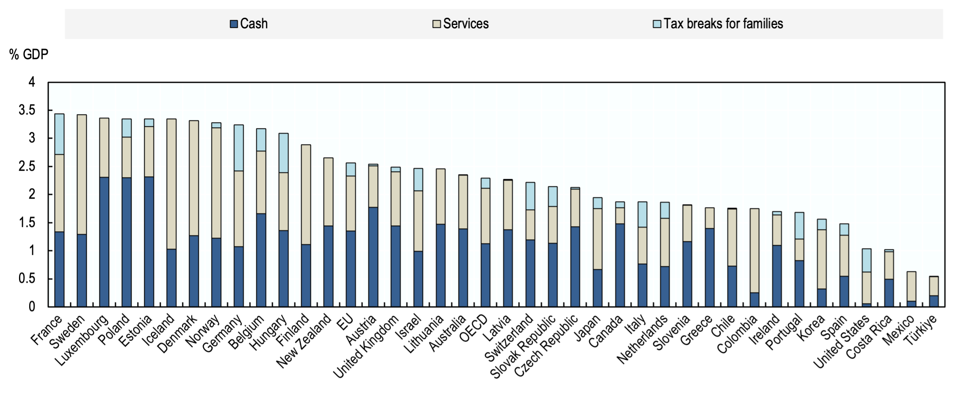

Figure 1: Public expenditure on family benefits by type of expenditure, in per cent of GDP, 2019.

Source: OECD (2019).

childcare is therefore an important policy question.

This work is connected to the empirical literature that examines the impact of childcare costs on female labour supply, a topic explored since Heckman (1974). For instance, Hotz and Miller (1988) investigate general childcare costs, while studies such as Blau and Hagy (1998) and Tekin (2007), and Baker, Gruber, and Milligan (2008) specifically focus on the influence of childcare subsidies. These latter studies consistently report substantial positive effects of childcare subsidies on female employment.

The study that most closely relates to this project is that of Guner, Kaygusuz, and Ventura (2020), who investigate the effect of child-related transfer schemes in the US. Their analysis is strongly motivated by the US institutional setting and estimates the effects of child-related transfer schemes that are conditional versus unconditional on market work, and those that are universal versus means-tested. The model developed in this paper follows this framework to investigate counterfactual policy experiments when child-related may depend on market work. Guner, Kaygusuz, and Ventura (2020) find that transfer schemes that are conditional on market work lead to the strongest increase in female labour supply. Moreover, their paper estimated a general equilibrium macroeconomic model with income heterogeneity, focusing on the effect of means-tested transfers across the income distribution.

The model developed in this paper instead takes a life-cycle perspective and focuses on the human capital accumulation channel to understand behavioural responses to child-related transfers. This paper further explores the intra-household decision process using the household bargaining model with limited commitment. These extensions are discussed in the following sections.

## Family labour supply through the lens of dynamic economic models

For the lower earning household member, there is a trade-off between working, which necessitates sourcing childcare outside the household, or not working and instead performing child-care related tasks. This trade-off is supported by a strong body of empirical evidence stating that women face higher career-costs of having children than men do (Kleven, Landais, and Egholt Søgaard 2018; Adda, Dustmann, and Stevens 2017). This effect is known as the child-penalty, and has been found to explain a large component of the long-term earnings inequality between men and women (Kleven, Landais, and Egholt Søgaard 2018). In Denmark, for example, the earnings and labour supply of men and women follow parallel trends before parenthood, but diverge sharply and persistently after children arrive (Kleven, Landais, and Egholt Søgaard 2018). Figure 1 presents a motivating example of this phenomenon, using household register data from Denmark.

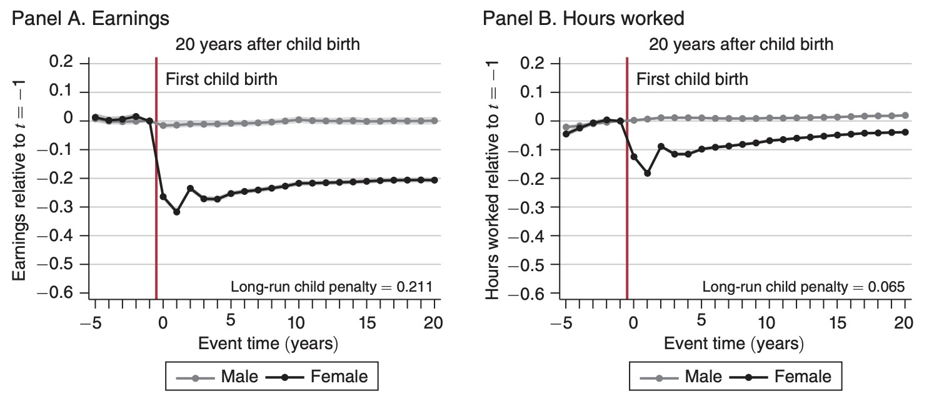

Figure 2: Event study showing the child-penalty in average earnings (panel A) and labour supply (panel B) of men and women upon the birth of the first child. This is produced from Danish register

data, taken from Kleven, Landais, and Egholt Søgaard (2018).

The model developed in this paper relates to a strand of literature that investigates male and female labour supply in a dynamic context. An essential feature of this model is endogenous human capital formation (learning by doing), which is accumulated from working and depreciates during career interruptions. This is the central mechanism used to explain the empirical child-penalty, as caused by career interruptions and human capital depreciation, which are set to be unequal between men and women.

It is worth noting that there is considerable disagreement in the literature about the causes of the child penalty, and this channel is certainly not the only one worth considering in the context of child-related transfers. Kleven, Landais, and Egholt Søgaard (2018) for example, attribute the child penalty largely to cultural norms and gender identity learned during childhood, while other authors focus on occupational choices (Adda, Dustmann, and Stevens 2017) and the role of endogenous fertility adjustments (Jakobsen, Jørgensen, and Low 2022), for example. However, this model abstracts from other drivers of the child-penalty and focuses on the human capital accumulation channel because it directly links labour market decisions with long-term wage trajectories and can be quantitatively assessed within a life-cycle framework.

My model builds from the seminal work of Keane (2016), who provides a theoretical analysis of the behavioural implications of introducing human capital into a life-cycle model. This framework is powerful as it captures the inter temporal trade-offs associated with consumption, savings, and labour supply, both at the intensive (work hours) and extensive (participation) margin. Previously, Imai and Keane (2004) note that estimating such a model, with two continuous state variables (human capital and assets), was very difficult due to computational constraints. This project therefore belongs to a new group of studies that estimates more elaborate life-cycle labour supply models with multiple continuous state variables (Foerster 2023; Jakobsen, Jørgensen, and Low 2022; Adda, Dustmann, and Stevens 2017; Voena 2015).

Household behavioural responses to child-related transfers in this model environment are governed by two drivers, the income and substitution effects. The income effect refers to the change in labour supply resulting from an increase in real income due to the transfer. This mechanism suggests that with additional income from childrelated transfers, households might reduce labour supply as they can now maintain the same income level while working fewer hours. The substitution effect, on the other hand, states that child-related transfers can change the relative attractiveness of work compared to leisure or home-care. For transfers that are conditional on working a certain number of hours, they effectively reduce the opportunity cost of working those hours, and are expected to increase labour supply up to the required threshold. Beyond this threshold, the substitution effect may diminish if additional work hours do not lead to further increases in benefits, potentially leading households to limit their labour supply to the minimum required to qualify for the transfers. The Marshall elasticity of labour supply captures the combined influence of the income and substitution effect, and is used to calculate household labour supply responses to child-related transfers predicted from the model proposed in this paper.

## Modelling decision-making within the household

This section briefly describes two different classes of models for household decisionmaking that are implemented in this project: the unitary model and the limited commitment model. Both can be understood in relation to the household utility function:

 (1)

where C*t* denotes the set of choice variables, S*t* denotes the set of state variables,

and *µt* is the bargaining power of household member 1.

In the unitary model, the household is treated as a single decision-making entity with a collective utility function. This approach assumes that all household resources and preferences can be aggregated into one utility function, effectively making the household act as if it has a single set of preferences. Therefore, in this model, the bargaining power *µt* is constant and not influenced by internal household dynamics, such that *µt* = *µ*∀*t*.

While the unitary model is straightforward and useful for deriving testable predictions about household behavior, it fails to account for individual preferences and intra-household negotiations (Chiappori and Mazzocco 2017). It oversimplifies by not considering how resources are distributed among household members, thus missing the nuances of individual welfare within the household.

The limited commitment model addresses these shortcomings by recognizing that household members have distinct utility functions and bargaining powers that can change over time based on their outside options and internal dynamics. Bargaining power under limited commitment is determined by endogenous factors and updated in some periods, ) (Chiappori and Mazzocco 2017).

The limited commitment model assumes that each household member can threaten to leave the relationship if their utility falls below their outside option, which enforces a renegotiation of the terms. This dynamic bargaining process ensures that the allocation of resources within the household is continually adjusted to reflect the members’ changing preferences and outside options, leading to Pareto-optimal outcomes (Mazzocco 2007).

This model has recently gained attention to study dynamic household decisionmaking in other related policy contexts, such as the move from joint to individual taxation (Bronson and Mazzocco 2023), the effect of divorce laws on savings and labour supply (Voena 2015), and the effect of laws related to alimony and child support (Foerster 2023). This suggests that this model is useful for analyzing the impact of child-related transfers on household labour supply decisions. By capturing the dynamic nature of intra-household negotiations and power shifts, the limited commitment model can provide a more realistic understanding of how such transfers influence individual labour supply, human capital accumulation, and overall household welfare. In particular, using this model provides a more elaborate interpretation of the trade-off associated with the choice to work and accumulate human capital, which improves earnings potential in the outside option and may improve bargaining power within the household, or not working, which may reduce one’s power share within the household. This model therefore allows for a more complex interplay of income and substitution effects when considering the impact of child-related transfers on decisions within the household. The theoretical process of the model is explained in greater detail in the next section.

# Model

In this section, I set out the recursive formulation for the life-cycle labour supply model introduced in this paper. It is worth noting that I refer to two different model specifications, the *extended model*, which is not solved, and the *unitary model*, which is solved and simulated. The *extended model* includes household bargaining, limited commitment with respect to power levels within the household (*µ* ∈ [0*,*1]), love shocks (*εt* ∼ *iid*N(0*,σψ*2 )), and endogenous divorce choices (*D*∗ ∈ {0*,*1}). The *unitary model*, on the other hand, is a special case of the *extended model*, where the power share within the household is constant (*µ* = 0*.*5∀*t*), there are no love shocks (*εt* ∼ *iid*N(0*,*0)), and there is no divorce (*D*∗ = 0∀*t*).

## Setup

In this model, households are initialised to comprise of two adult members, a woman and a man, who are indicated by *j* ∈ {*w,m*}. Households choose individual consumption,

*cj,t*, public consumption, *ct*, and individual working hours, *hj,t*. Individual preferences are of the CES type,

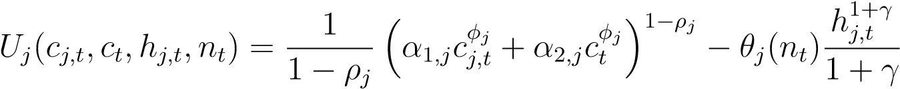 (2)

with the dis-utility of work depending on the presence of a child *nt*,

*θj* = *θ*0*,j* + *θ*1*,jnt.* (3)

The household budget constraint for a couple is

*At* + *ct* + *cw,t* + *cm,t* =*RAt*−1 + *Yw,t*(*ww,t,hw,t*) + *Ym,t*(*wm,t,hm,t*)

+ C*couple*(*nt,hm,t,hw,t,ww,t,wm,t*) (4)

where *At*−1 is beginning of period *t* wealth, and C*couple*(*nt,hm,t,hw,t,ww,t,wm,t*) are

the child-related transfers a couple receives, which are outlined in the next section.

*Yj,t* is labour income of member *j*, which is based on exogenous wages and their endogenous labour supply choice,

*Yj,t* = *wj,thj,t.* (5)

Human capital of each member, *Kj,t*, is accumulated from working, which also enters into the wage function,

log(*wj,t*) = *α*0*,j* + *α*1*,jKj,t* (6)

*Kj,t*+1 = (1 − *δ*)*Kj,t* + *hj,t.* (7)

Including the above endogenous wage process with human capital formation is a crucial element of this model, as it captures the gender-specific consequences of disrupted labor supply upon childbirth.

In each period, a couple faces the random arrival of a child. For simplicity, I assume that households can only have one child, and once a child is born, it remains with them in all future periods,

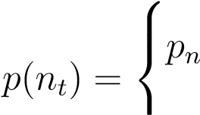if *nt* = 0

(8)

0 if *nt* = 1*.*



*nt* + 1 with probability *p*(*nt*)

*nt*+1 = (9)

*nt* with probability 1 − *p*(*nt*)*.*

In each period, the couple receives a random value of remaining as a couple, *ψt*. This is otherwise known as a ’love shock’ and it follows a unit-root process,

*ψt*+1 = *ψt* + *εt*+1 (10)

where *εt* ∼ *iid*N(0*,σψ*2 ). The state variables for a couple are then S*t* = (*ψt,At*−1*,nt,Kw,t,Km,t*)

besides the bargaining power coming into the period, *µt*−1.

## Child-related transfers

If a child is present, the household may receive child-related transfers. Child-related transfers may depend on whether a parent is single or married,

*Ccouple*(*nt,hm,t,hw,t,ww,t,wm,t*) =*C*1(*nt*) + *C*2(*nt,Ym,t,Yw,t*)

+ [*C*3(*nt*) + *C*4(*nt,Ym,t,Yw,t*)] · 1(*hw,t > χ*) (11)

*Csingle*(*nt,hj,t,wj,t*) =*C*1(*nt*) + *C*2(*nt,Yj,t*)

+ [*C*3(*nt*) + *C*4(*nt,Yj,t*)] · 1(*hj,t > χ*) (12)

where *χ* ∈ [0*,*1] denotes some minimum level of work hours to qualify for transfers that are conditional on hours worked.[1]

This formulation allows for four different flavours of child-related transfers across two dimensions, including those that are conditional/unconditional on market work and those that are universal/means-tested. Table 1 illustrates the different components of child-related transfers in this model.

## Bellman equations

The value of entering a period as a couple is

*Vj,tm*(*ψt,At*−1*,µt*−1*,Kw,t,Km,t,nt*−1) =*Dt⋆Vj,tm*→*s*(*κjAt*−1*,Kj,t*−1*,nt*−1)

+ (1 − *Dt⋆*)*Vj,tm*→*m*(*ψt,At*−1*,µt*−1*,Kw,t*−1*,Km,t*−1*,nt*−1) (13)

|  |  |  |
| --- | --- | --- |
|  | Universal | Means-tested |
| Unconditional on work | *C*1(*nt*) = *ϕ*0 | *C*2(*nt,Yt*) = *ϕ*1 − *ϕ*2*Yt* |
| Conditional on work | *C*3(*nt*) = *ϕ*3 | *C*4(*nt,Yt*) = *ϕ*4 − *ϕ*5*Yt* |

Table 1: A taxonomy of child-related transfers, inspired by that of (Guner, Kaygusuz, and Ventura 2020). *Yt* expresses income on the household level.

where *κj* is the share of household wealth member *j* gets in case of divorce (*κw*+*κm* = 1). The choice to divorce,, is discussed below. The value of transitioning into single-hood



s.t. *At* =*RAt*−1 + *Yj,t* − *ct* − *cj,t* + *Csingle*(*nt,hj,t,wj,t*) (14)

where ), since single-hood is treated as an absorbing state. This means that once a person becomes single, they remain single for all future periods.[2]

The value of remaining married is

*Vj,tm*→*m*(*ψt,At*−1*,µt*−1*,nt*−1*,Kw,t*−1*,Km,t*−1) = *Uj*(*c⋆j,t,c⋆t ,h⋆w,t,h⋆m,t*) + *ψt*

+ *β*E*t*[*Vj,tm*+1(*ψt*+1*,At,µt,Kw,t,Km,t,nt*)] (15)

s.t. *At* = *RAt*−1 + *Yw,t* + *Ym,t*

− (*c⋆t* + *c⋆w,t* + *c⋆m,t*) + *Ccouple*(*nt,hm,t,hw,t,ww,t,wm,t*) (16)

*ψt*+1 = *ψt* + *εt*+1 (17)

Solving this problem follows a two-step process, which is laid out in the following sections.

## Solving the unconstrained problem of couples

The optimal value of (*c⋆w,t,c⋆m,t,c⋆t ,h⋆m,t,h⋆w,t*) and *µt*, along with *Dt⋆*, are found in the following way.

Let the solution to a problem of couples, under the condition that they remain together taking the bargaining power, *µ*, as given be

*Vj,tm*→*m*(*ψt,At*−1*,µt*−1*,nt*−1*,Kw,t*−1*,Km,t*−1) =*Uj*(*c⋆j,t,c⋆t ,h⋆w,t,h⋆m,t,nt*) + *ψt*

+ *β*E*t*[*Vj,tm*+1(*ψt*+1*,At,µt,Kw,t,Km,t,nt*)] (18)

s.t. *At* =*RAt*−1 + *Yw,t* + *Ym,t* − (*c⋆t* + *c⋆w,t* + *c⋆m,t*)

+ *Ccouple*(*nt,hm,t,hw,t,ww,t,wm,t*) (19)

*ψt*+1 =*ψt* + *εt*+1*.* (20)

The value-of-choice function, which gives the value associated with choices of consumption and hours worked for both spouses, given some *µ* is

*vj,t*(*ψt,At*−1*,Kw,t*−1*,Km,t*−1*,µ,cw,t,cm,t,ct,hw,t,hm,t,nt*) =*Uj*(*cj,t,ct,hj,t,nt*) + *ψt*

+ *β*E*t*[*Vj,tm*+1(*ψt*+1*,At,µ*)]*.* (21)

This first step involves solving the unconstrained problem, assuming that none of the participation constraints are violated, such that *µ* = *µt* = *µt*−1. This gives

*c*˜*w,t*(*µt*−1)*,c*˜*m,t*(*µt*−1)*,c*˜*t*(*µt*−1)*,h*˜*m,t*(*µt*−1)*,h*˜*w,t*(*µt*−1) and individual values of marriage as *vj,t*(*ψt,At*−1*,µt*−1*,c*˜*w,t*(*µt*−1)*,c*˜*m,t*(*µt*−1)*,c*˜*t*(*µt*−1)*,h*˜*m,t*(*µt*−1)*,h*˜*w,t*(*µt*−1)).

## Checking the participation constraints

The second step involves checking the participation constraints for three cases. For this purpose let

*Sj,t*(*µ*) =*Sj,t*(*ψt,At*−1*,µ,cw,t,cm,t,ct*)

=*vj,t*(*ψt,At*−1*,Kw,t*−1*,Km,t*−1*,µ,cw,t,cm,t,ct,hw,t,hm,t,nt*)

− *Vj,tm*→*s*(*κjAt*−1*,Kj,t*−1*,nt*−1) (22)

denote the marital surplus of household member *j*. The three cases are as follows:

1. If *Sj,t*(*µt*−1) ≥ 0 for both *j* = *w,m*, they remain married and keep the bar-

gaining power unchanged. As such, I have *µt* = *µt*−1, (*c⋆w,t,c⋆m,t,c⋆t ,h⋆m,t,h⋆w,t*) =

(*c*˜*w,t*(*µt*−1)*,c*˜*m,t*(*µt*−1)*,c*˜*t*(*µt*−1)*,h*˜*m,t*(*µt*−1)*,h*˜*w,t*(*µt*−1)), and *Dt⋆* = 0.

1. If *Sj,t*(*µt*−1) *<* 0 for both *j* = *w,m*, they divorce. As such = 1 and only

) matters.

1. If one household member, the woman, for example, has a negative marital surplus while the man has a positive marital surplus, they re-negotiate *µt*. Renegotiation happens by finding the lowest value ˜*µ* that solves

*µ*˜ : *Sw,t*(*µ*˜) = 0

making her just indifferent between remaining married and divorcing. If the man also has a positive surplus for this value, *Sm,t*(*µ*˜) ≥ 0, they remain married and increase the bargaining power of the woman. In turn, *µt* = *µ*˜, (*c⋆w,t,c⋆m,t,c⋆t ,h⋆m,t,h⋆w,t*) =

(*c*˜*w,t*(*µ*˜)*,c*˜*m,t*(*µ*˜)*,c*˜*t*(*µ*˜)*,h*˜*m,t*(*µt*−1)*,h*˜*w,t*(*µt*−1)), and *Dt⋆* = 0. If, on the other hand, *Sm,t*(*µ*˜) *<*

0, there is no value of *µ* that can sustain the marriage, and the couple divorces, setting



# Results

## Solution method

The above model sets out a dynamic programming problem, which is solved numerically using backward induction. This involves fixing grids for state variables and applying value-function iteration (VFI), using three-dimensional linear interpolation. Since there are five state variables, and four continuous choice variables, computational speed is a considerable constraint when using VFI. For example, solving the *unitary model* took approximately 43 minutes to run. Handling the love shocks in the *extended model*, as well as the additional discrete choice to divorce, could not be achieved for this paper.

## Calibration

Important consideration was made to set the dis-utility of working while children are present to be higher for woman than for men (*θ*1*,w > θ*1*,m*). This is the main driver of asymmetric labour supply behaviour over time in this model, which is motivated from the findings of Adda, Dustmann, and Stevens (2017), Kleven, Landais, and Egholt Søgaard (2018), and Voena (2015). The values of other parameters in this model are set somewhat arbitrarily. Values of calibrated parameters can be found in the appendix, and a discussion of the potential of using this model for structural estimation is provided in the discussion section.

## Simulated labour supply

After solving the *unitary model*, it is simulated for 1,000 households over 10 periods. A time period in this setup is a year, and the model can therefore relate to couples who face fertility over a 10 year period starting from age 25. Figure 3 presents results for simulated labour supply for households under both child-related transfer regimes. In this simulation, one type of child-related transfer regime is implemented at a time, while the other is set to zero. For example, for the simulation titled ’Unconditional on market work’, *ϕ*1 is set equal to zero, to isolate the effect of *ϕ*0 (the unconditional transfer).

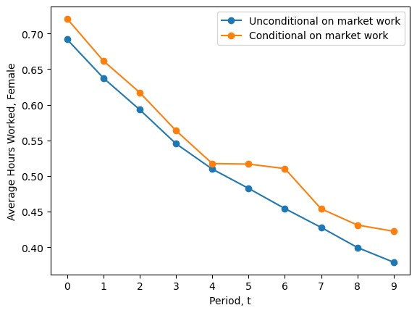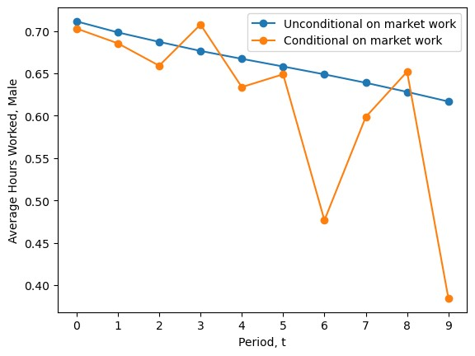

(a) Female labour supply (b) Male labour supply

Figure 3: Simulated labour supply by gender, and type of child-related transfer implemented.

As seen in Figure 3, simulated average labour supply follows a downward time trend for both males and females. This is due to the effect of the random arrival of children on the dis-utility of work. As parents receive a dis-utility of working that is dependent on the presence of a child, parents anticipate the future arrival of a child and tend to have greater labour supply before the child arrives than afterwards. This effect is greater for women than men in the calibration of this model, because women face a

higher dis-utility of work associated with children than men do (*θ*1*,w > θ*1*,m >* 0).

The other noticeable pattern is the relative tapering-off of the gradient in average female labour supply from period 5, for the simulated model with transfers that are conditional on market work. This may be explained by the setting of a minimum level of market work hours to qualify for transfers (*χ* = 0*.*5, in this calibration). The transfer distorts female labour supply in the model, and leads to females working more to be eligible for the transfer in some periods than they otherwise would. This finding may be policy-relevant as it highlights that female labour supply may be somewhat responsive to the level of *χ*.

The response of male labour supply to transfers that are conditional on market work, on the other hand, is highly volatile in the simulation results. The sharp fall in male labour supply in period 6, for example, may be explained by the relative increase in female labour supply in this period, to gain eligibility for the conditional transfer. Men in this model therefore reduce their labour supply to smooth household income. There are also relatively sharp increases in average male labour supply in periods 3 and 5, which may be due to a motive to accumulate more human capital in anticipation of the aforementioned fall in labour supply in period 6. However, the mechanism driving this volatility is relatively unclear, and warrants further investigation.

It is worth noting that the simulation results for labour supply presented in figure 3 are not informative about the relative effect sizes of the different child-related transfer regimes on labour supply. This is because the two different transfer regimes are not set to be budget-neutral from the perspective of the government (so that the total expenditure on each of the programs are the same). Implementing this requires first defining a level of total government spending on the transfers, then searching over different parameter values of *ϕ*0 and *ϕ*1. This was attempted using a numerical optimiser, however, it was not feasible due to speed constraints.[3]

## Simulated labour supply elasticities

In order to comment on the relative effect-sizes of the different child-related transfer regimes, I simulated the responses to counter-factual increases in each type of transfer on the average labour supply elasticity of men and women in the model. The counterfactuals are defined as an anticipated 10% increase in child-related transfers announced before the first period begins, which is implemented for both types of child-related transfers. The results are presented in Figure 4.

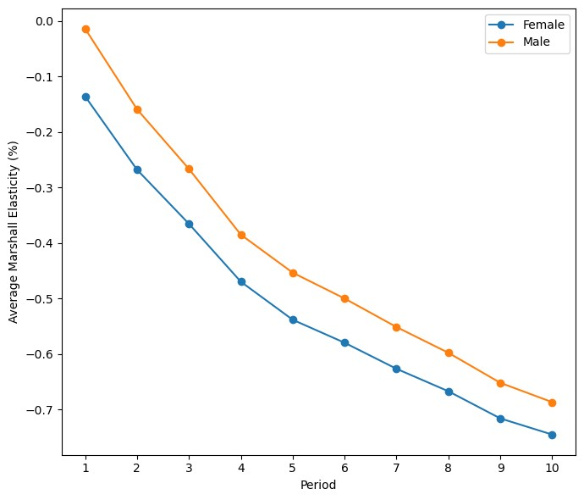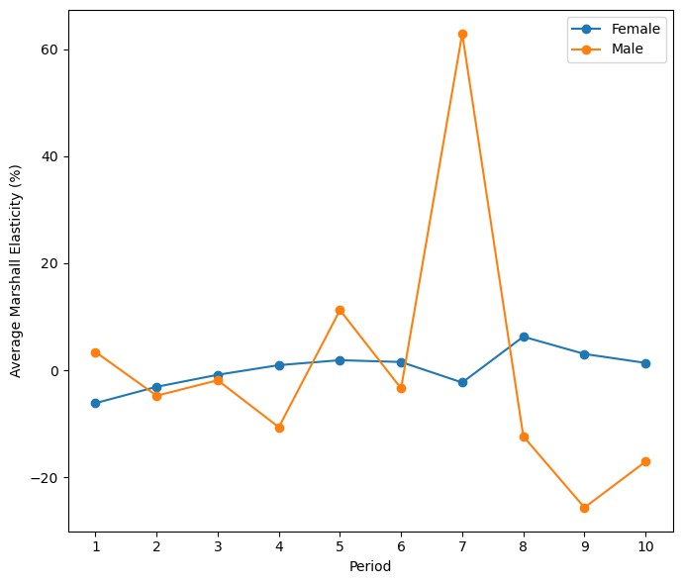

(a) Uncondtional on market work (b) Conditional on market work

Figure 4: Simulated average Marshall labour supply elasticities to a counter-factual 10% increase in

child-related transfers, by type of child-related transfer.

The Marshall elasticities shown in Figure 4 illustrate the labour supply responses resulting from the counterfactual policy experiments, reflecting the combined influences of the income and substitution effect. It is worth noting that these Marshall elasticities associated with both types of child-related transfers are not constant over time. This is a characteristic of using a life-cycle dynamic labour supply model rather than a static one (Keane and Wasi 2016).

The scale of the Marshall elasticities under both child-related transfer regimes are not informative, since model parameters are not fitted to actual data. What is informative, however, are the sign and relative difference in the child-related transfers for men and women in the model. For transfers that are unconditional on market work, average labour supply elasticities are negative and increasing (in absolute value) over time. This supports the theoretical prediction that increasing child-related transfers means that households now need to work less to receive the same disposable income (the income effect). Moreover, the elasticity of labour supply with respect to the policy is higher (in absolute value terms) for women than for men in all periods. The policy implication suggests that increasing transfers that are unconditional on market work lead both men and women to reduce their labour supply in all periods, and this effect is stronger for women than for men.

For child-related transfers that are conditional on market work, the story is more complicated. The substitution effect is likely more relevant here, as the transfer requires women to work over a certain threshold of hours (*χ*). Theory may predict that this creates an incentive for women to increase their labour supply to qualify for the transfer, then reduce labour supply more drastically once they fall below the threshold (*χ*). This effect is somewhat evident in period 7, which is the point where female labour supply, on average, falls below the threshold, as seen in Figure 3(a). However, this effect does not persist past period 7 (as theory may suggest), but instead increases to a positive level and with a small negative gradient. This latter result is unexpected and it is unclear how it can be explained in terms of the income and substitution effects. Moreover, the Marshall elasticity of male labour supply is highly volatile and seems to act as a counterbalance to the the changes of female labour supply around the threshold level

(*χ*).

# Discussion

## Insights from the *unitary model*

Simulation results from the unitary model provide several insights into household labour supply responses to child-related transfers. For transfers that are unconditional on market work, the model suggests that the labour supply elasticity is time-varying and generally negative, and of greater magnitude for women than men. This suggests that policies aimed at increasing female labour force participation by providing households with child-related transfers that are independent of market work may be ineffective.

The negative labour supply elasticity finding with respect to unconditional transfers is contrary to the findings of all the empirical studies mentioned to motivate this paper Guner, Kaygusuz, and Ventura (2020) and Rogerson (2007). One potential explanation is that the gender-specific dis-utility of working that depends on the presence of children (*θ*1*,m* and *θ*1*,w*), is calibrated too low. This may result in the substitution effect being overpowered by the income effect. A future study may investigate this by calculating the Frisch elasticity of labour supply with respect to an unanticipated, transitory increase in unconditional child-related transfers (Keane 2016). Doing so would isolate the substitution effect quantitatively, which was not possible using the Marshallian elasticity framework in this paper. Another possible driver of the unexpected results is the effect of human capital accumulation on wage trajectories (*α*1*,j*). Perhaps, the benefit of working to increase future wages is set too low for the substitution effect to play a significant role. Calibrating both of these parameters empirically, or estimating them within the model, may be avenue for future research to clarify these questions.

For transfers that are conditional on market work, the results are varied. The results suggest that for women whose labour supply choice is close to the threshold that qualifies them for the conditional transfer (*χ*), they tend to remain working just enough to receive the transfer. This finding may be relevant to a policy-maker with an objective to encourage a certain level of labour supply (for part-time work, for example), or a policy-maker may wish to avoid this issue by including a progressive system of child-related transfers that are conditional on work. Male labour supply under conditional transfers is found to highly volatile, and in some periods counteracts the movement in female labour supply to smooth household income. This result is also unexpected, and is contrary to other empirical studies which find male labour supply to be relatively unresponsive to changes in government transfers (Adda, Dustmann, and Stevens 2017; Jakobsen, Jørgensen, and Low 2022; Keane and Wasi 2016). This result may be further investigated by estimating model parameters empirically. Since male labour supply in this model seems to be far more volatile than what is seen empirically, it may be appropriate to introduce labour market search-and-match frictions or impose discrete choices for labour supply (making them decide between part-time or full-time, for example).

## Limitations

As already alluded to, insights from this model are limited in three important respects, (1) the model is likely too simple to capture many important dynamics affecting household labour supply decisions, (2) it is not calibrated to any empirical moments, nor does it produce parameter estimates, and (3) the *extended model*, which includes household bargaining and limited commitment, is not solved. All of these limitations are related to the problem of computational speed that arises when solving the model numerically.

One possible way to overcome the challenge of computational speed is to solve the *extended model* using the endogenous grid-point method (EGM), as originally proposed by Carroll (2006). This is known to provide impressive speed gains compared to standard VFI (Druedahl and Jørgensen 2017). However, using EGM is not straight-forward because it requires an analytical expression for the inverse marginal utility function, which is not known in this case. Hallengreen, Jørgensen, and Olesen (2024) propose a way to do this by finding the numerical derivative of the inverse utility function (iEGM), which may be an avenue to solve this model in a future project.

The model developed in this paper is intended to be the most simple way to capture dynamic labour supply choices with human capital formation, including household bargaining with limited commitment, and the arrival of children. There are many potential extensions of this model to make it more realistic in a particular institutional context. For example, it may be interesting to treat fertility as an endogenous choice and allow for the arrival of more than one child, as is done in a similar context in the study of Jakobsen, Jørgensen, and Low (2022). Moreover, other important choices that accompany labour supply and fertility, such as marriage and education choices, may also be made endogenous.

Another possible extension of this paper is to calibrate it to empirical moments. Key variables from household-level data that could be used include consumption profiles, child-births, marriage and divorce transitions, wages and time-use data. The method of simulated distance (MSD) could then be employed to estimate unobserved parameters. Of particular interest, for example, are the components in the dis-utility of work functions for both genders (the contents of *θ*(*nt*)), and the role of human capital accumulation in the wage process (*α*1*,j*). Calibrating this model empirically would be especially important given the confounding policy implications the model provides regarding child-related transfers.

**References**

Adda, J´eroˆme, Christian Dustmann, and Katrien Stevens. 2017. “The Career Costs of Children.” Publisher: The University of Chicago Press, *Journal of Political Economy* 125, no. 2 (April): 293–337. issn: 0022-3808, accessed May 23, 2024. [https: //doi.org/10.1086/690952.](https://doi.org/10.1086/690952) [https://www.journals.uchicago.edu/doi/abs/10.1086/ 690952.](https://www.journals.uchicago.edu/doi/abs/10.1086/690952)

Baker, Michael, Jonathan Gruber, and Kevin Milligan. 2008. “Universal Child Care, Maternal Labor Supply, and Family Well-Being.” Publisher: The University of Chicago Press, *Journal of Political Economy* 116 (4): 709–745. issn: 0022-3808, accessed May 31, 2024. [https://doi.org/10.1086/591908.](https://doi.org/10.1086/591908) [https://www.jstor.org/ stable/10.1086/591908.](https://www.jstor.org/stable/10.1086/591908)

Blau, David M., and Alison P. Hagy. 1998. “The Demand for Quality in Child Care.” Publisher: The University of Chicago Press, *Journal of Political Economy* 106, no.

1 (February): 104–146. issn: 0022-3808, accessed May 31, 2024. [https://doi.org/ 10.1086/250004.](https://doi.org/10.1086/250004) [https://www.journals.uchicago.edu/doi/abs/10.1086/250004.](https://www.journals.uchicago.edu/doi/abs/10.1086/250004)

Bronson, Mary Ann, and Maurizio Mazzocco. 2023. “Cohort Size and the Marriage

Market: Explaining Nearly a Century of Changes in US Marriage Rates.” Publisher: The University of Chicago Press, *Journal of Labor Economics* (January): 000–000. issn: 0734-306X, accessed May 31, 2024. [https://doi.org/10.1086/724047.](https://doi.org/10.1086/724047) [https: //www.journals.uchicago.edu/doi/10.1086/724047.](https://www.journals.uchicago.edu/doi/10.1086/724047)

Carroll, Christopher D. 2006. “The method of endogenous gridpoints for solving dynamic stochastic optimization problems.” *Economics Letters* 91, no. 3 (June): 312–320. issn: 0165-1765, accessed May 30, 2024. [https://doi.org/10.1016/ j.econlet.2005.09.013.](https://doi.org/10.1016/j.econlet.2005.09.013) [https://www.sciencedirect.com/science/article/pii/ S0165176505003368.](https://www.sciencedirect.com/science/article/pii/S0165176505003368)

Chiappori, Pierre-Andre, and Maurizio Mazzocco. 2017. “Static and Intertemporal Household Decisions” [in en]. *Journal of Economic Literature* 55, no. 3 (September): 985–1045. issn: 0022-0515, accessed May 31, 2024. [https://doi.org/10.1257/ jel.20150715.](https://doi.org/10.1257/jel.20150715) [https://www.aeaweb.org/articles?id=10.1257/jel.20150715.](https://www.aeaweb.org/articles?id=10.1257/jel.20150715)

Druedahl, Jeppe, and Thomas Høgholm Jørgensen. 2017. “A general endogenous grid method for multi-dimensional models with non-convexities and constraints.” *Journal of Economic Dynamics and Control* 74 (January): 87–107. issn: 0165-1889, accessed May 30, 2024. [https://doi.org/10.1016/j.jedc.2016.11.005.](https://doi.org/10.1016/j.jedc.2016.11.005) [https: //www.sciencedirect.com/science/article/pii/S0165188916301920.](https://www.sciencedirect.com/science/article/pii/S0165188916301920)

Foerster, Hanno. 2023. *Untying the Knot: How Child Support and Alimony Affect Couples’ Decisions and Welfare.* Boston College Working Papers in Economics 1043. Boston College Department of Economics, December. Accessed April 29, 2024. [https://econpapers.repec.org/paper/bocbocoec/1043.htm.](https://econpapers.repec.org/paper/bocbocoec/1043.htm)

Guner, Nezih, Remzi Kaygusuz, and Gustavo Ventura. 2020. “Child-Related Transfers, Household Labour Supply, and Welfare.” *The Review of Economic Studies* 87, no. 5 (October): 2290–2321. issn: 0034-6527, accessed April 23, 2024. [https://doi.org/ 10.1093/restud/rdaa011.](https://doi.org/10.1093/restud/rdaa011) [https://doi.org/10.1093/restud/rdaa011.](https://doi.org/10.1093/restud/rdaa011)

Hallengreen, Adam, Thomas Høgholm Jørgensen, and Annasofie M. Olesen. 2024. “The Endogenous Grid Method without Analytical Inverse Marginal Utility” [in en]. *SSRN Electronic Journal,* issn: 1556-5068, accessed May 30, 2024. [https://doi. org/10.2139/ssrn.4830404.](https://doi.org/10.2139/ssrn.4830404) [https://www.ssrn.com/abstract=4830404.](https://www.ssrn.com/abstract=4830404)

Heckman, James J. 1974. “Effects of Child-Care Programs on Women’s Work Effort.” Publisher: The University of Chicago Press, *Journal of Political Economy* 82, no. 2, Part 2 (March): S136–S163. issn: 0022-3808, accessed May 31, 2024. [https: //doi.org/10.1086/260297.](https://doi.org/10.1086/260297) [https://www.journals.uchicago.edu/doi/abs/10.1086/ 260297.](https://www.journals.uchicago.edu/doi/abs/10.1086/260297)

Hotz, V. Joseph, and Robert A. Miller. 1988. “An Empirical Analysis of Life Cycle Fertility and Female Labor Supply.” Publisher: [Wiley, Econometric Society], *Econometrica* 56 (1): 91–118. issn: 0012-9682, accessed May 31, 2024. [https://doi.org/ 10.2307/1911843.](https://doi.org/10.2307/1911843) [https://www.jstor.org/stable/1911843.](https://www.jstor.org/stable/1911843)

Imai, Susumu, and Michael P. Keane. 2004. “Intertemporal Labor Supply and Human

Capital Accumulation*” [in en]. Eprint: https://onlinelibrary.wiley.com/doi/pdf/10.1111/j.1468-

2354.2004.00138.x, *International Economic Review* 45 (2): 601–641. issn: 14682354, accessed May 24, 2024. [https://doi.org/10.1111/j.1468-2354.2004.00138.x.](https://doi.org/10.1111/j.1468-2354.2004.00138.x) [https://onlinelibrary.wiley.com/doi/abs/10.1111/j.1468-2354.2004.00138.x.](https://onlinelibrary.wiley.com/doi/abs/10.1111/j.1468-2354.2004.00138.x)

Jakobsen, Katrine Marie, Thomas Jørgensen, and Hamish Low. 2022. *Fertility and Family Labor Supply* [in en]. SSRN Scholarly Paper. Rochester, NY. Accessed May 25, 2024. [https://doi.org/10.2139/ssrn.4118084.](https://doi.org/10.2139/ssrn.4118084) [https://papers.ssrn.com/abstract= 4118084.](https://papers.ssrn.com/abstract=4118084)

Keane, Michael P. 2016. “Life-cycle Labour Supply with Human Capital: Econometric and Behavioural Implications” [in en]. Eprint: https://onlinelibrary.wiley.com/doi/pdf/10.1111/ec *The Economic Journal* 126 (592): 546–577. issn: 1468-0297, accessed May 24, 2024. [https://doi.org/10.1111/ecoj.12363.](https://doi.org/10.1111/ecoj.12363) [https://onlinelibrary.wiley.com/doi/abs/10. 1111/ecoj.12363.](https://onlinelibrary.wiley.com/doi/abs/10.1111/ecoj.12363)

Keane, Michael P., and Nada Wasi. 2016. “Labour Supply: The Roles of Human Capital and The Extensive Margin” [in en]. Eprint: https://onlinelibrary.wiley.com/doi/pdf/10.1111/ecoj.

*The Economic Journal* 126 (592): 578–617. issn: 1468-0297, accessed May 24, 2024. [https://doi.org/10.1111/ecoj.12362.](https://doi.org/10.1111/ecoj.12362) [https://onlinelibrary.wiley.com/doi/abs/10. 1111/ecoj.12362.](https://onlinelibrary.wiley.com/doi/abs/10.1111/ecoj.12362)

Kleven, Henrik, Camille Landais, and Jakob Egholt Søgaard. 2018. *Children and Gender Inequality: Evidence from Denmark.* Working Paper, January. Accessed March 1, 2024. [https://doi.org/10.3386/w24219.](https://doi.org/10.3386/w24219) [https://www.nber.org/papers/w24219.](https://www.nber.org/papers/w24219)

Mazzocco, Maurizio. 2007. “Household Intertemporal Behaviour: A Collective Characterization and a Test of Commitment.” *The Review of Economic Studies* 74, no. 3 (July): 857–895. issn: 0034-6527, accessed May 31, 2024. [https://doi.org/10.1111/](https://doi.org/10.1111/j.1467-937X.2007.00447.x)

[j.1467-937X.2007.00447.x.](https://doi.org/10.1111/j.1467-937X.2007.00447.x) [https://doi.org/10.1111/j.1467-937X.2007.00447.x.](https://doi.org/10.1111/j.1467-937X.2007.00447.x)

OECD. 2019. *OECD Reviews of Labour Market and Social Policies* [in en]. Text. Accessed May 23, 2024. [https://www.oecd-ilibrary.org/employment/oecd-reviewsof-labour-market-and-social-policies](https://www.oecd-ilibrary.org/employment/oecd-reviews-of-labour-market-and-social-policies_20743408) [20743408.](https://www.oecd-ilibrary.org/employment/oecd-reviews-of-labour-market-and-social-policies_20743408)

Rogerson, Richard. 2007. “Taxation and market work: is Scandinavia an outlier?” Publisher: Springer, *Economic Theory* 32 (1): 59–85. issn: 0938-2259, accessed April 29, 2024. [https://www.jstor.org/stable/27822546.](https://www.jstor.org/stable/27822546)

Tekin, Erdal. 2007. “Childcare Subsidies, Wages, and Employment of Single Mothers” [in en]. Publisher: University of Wisconsin Press Section: Articles, *Journal of Human Resources* XLII, no. 2 (March): 453–487. issn: 0022-166X, 1548-8004, accessed May 31, 2024. [https://doi.org/10.3368/jhr.XLII.2.453.](https://doi.org/10.3368/jhr.XLII.2.453) [https://jhr.uwpress.org/ content/XLII/2/453.](https://jhr.uwpress.org/content/XLII/2/453)

Voena, Alessandra. 2015. “Yours, Mine, and Ours: Do Divorce Laws Affect the Intertemporal Behavior of Married Couples?” [In en]. *American Economic Review* 105, no. 8 (August): 2295–2332. issn: 0002-8282, accessed May 30, 2024. [https://doi.org/10.](https://doi.org/10.1257/aer.20120234)

[1257/aer.20120234.](https://doi.org/10.1257/aer.20120234) [https://www.aeaweb.org/articles?id=10.1257/aer.20120234.](https://www.aeaweb.org/articles?id=10.1257/aer.20120234)

**Appendix**

1. . In the couple’s problem, transfers that are conditional on working target female labour supply, because I found this was the only way to generate an interesting behavioural response using the model. If, instead, conditional transfers depend on both partners working above some amount, *χ*, then the labour supply response is identical to the case with unconditional transfers.
2. . Treating single-hood as an absorbing state drastically simplifies the problem, but is relatively unrealistic (due to the possibility of re-partnering). This requirement may hopefully be relaxed in future iterations of the model.
3. . Since solving each version of the model takes approximately 43 minutes, searching over different levels of *ϕ*0 and *ϕ*1 and re-solving the model is very computationally expensive.